**I have 2000 mp3 songs each around 3mb. How many 4gb usb flashdrive do I need to have them back up?**

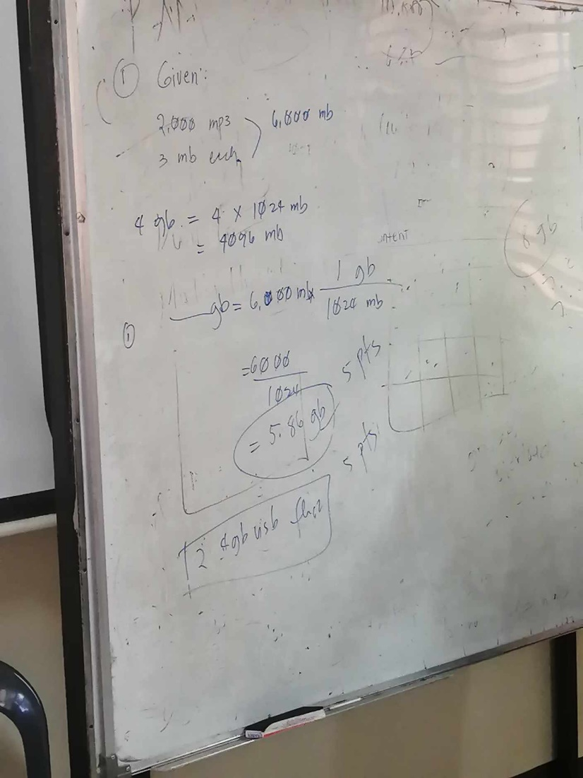

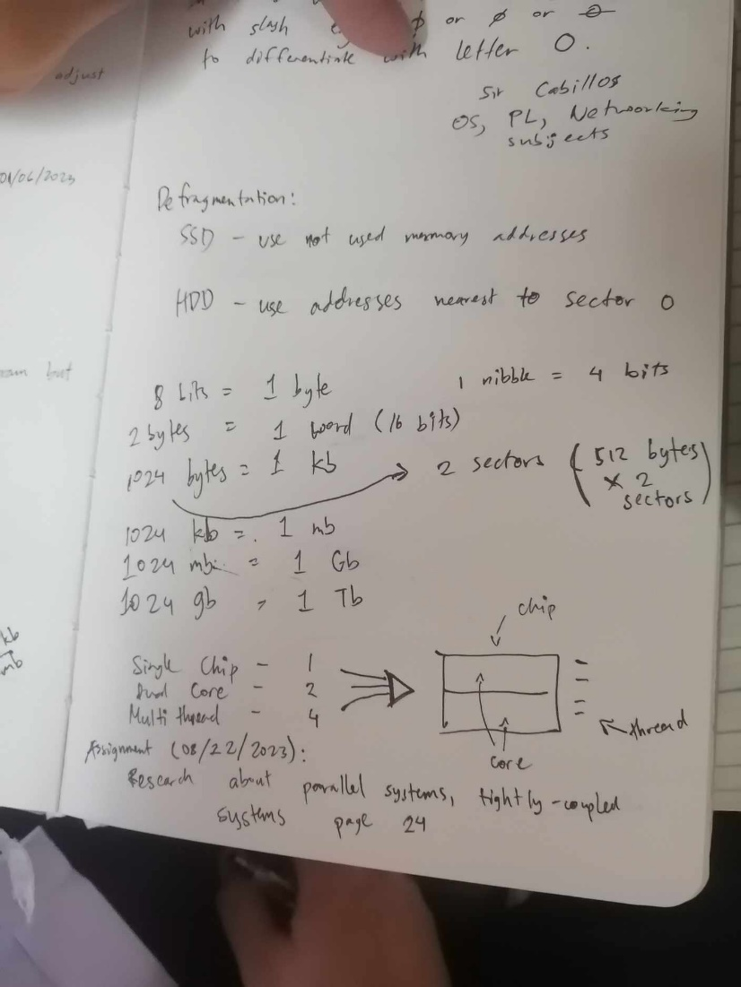

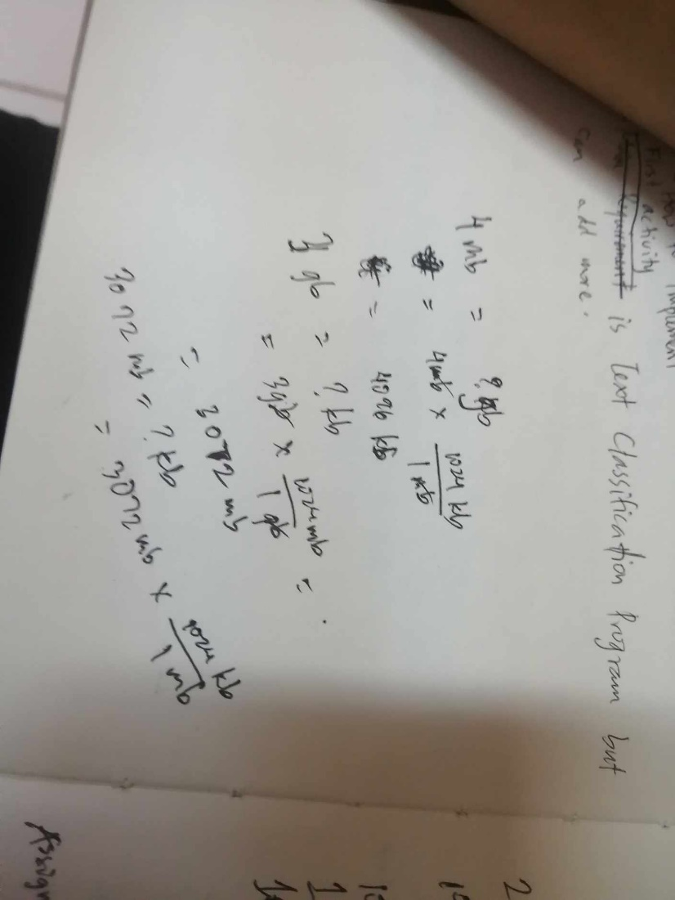

I was told to copy movies to my external HDD which is 256gb. If each movie is around 4096mb how many movies would fit the external HDD.